**LAB – 2**

**NoSQL MongoDB**

**Amit Kumar Sahu**

**18mis7250**

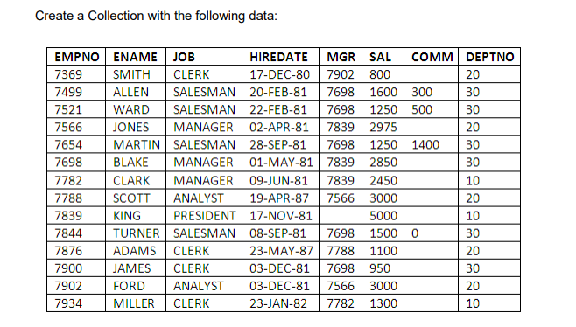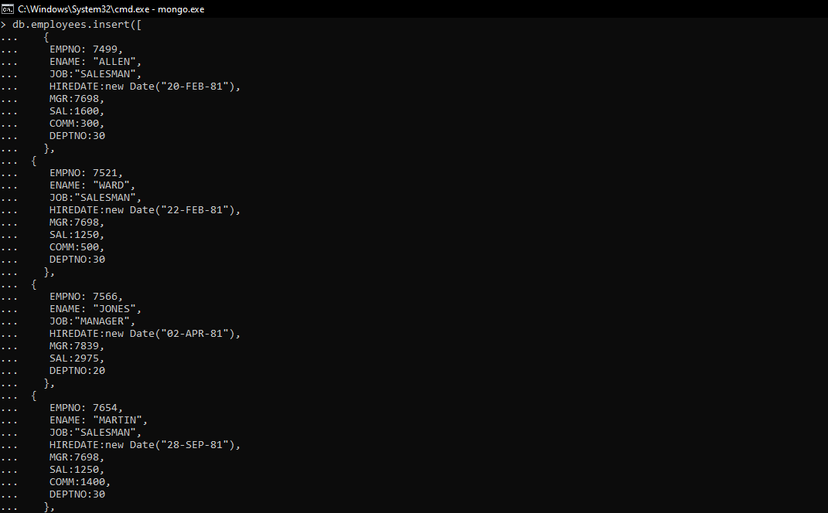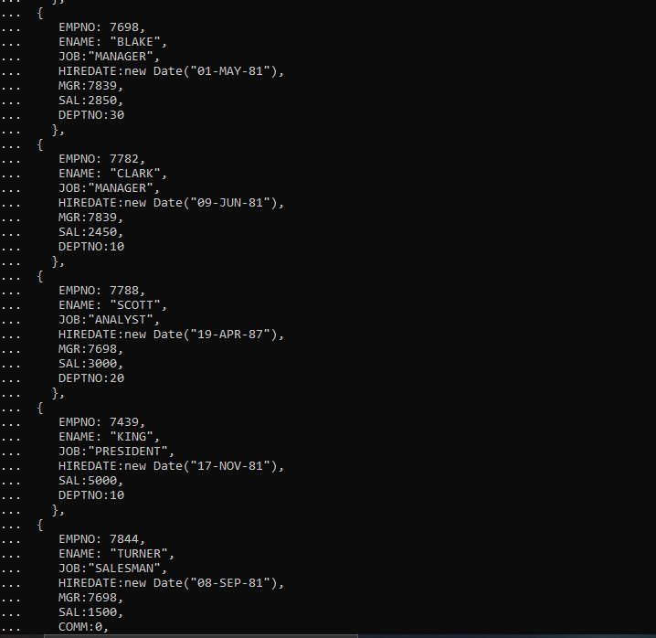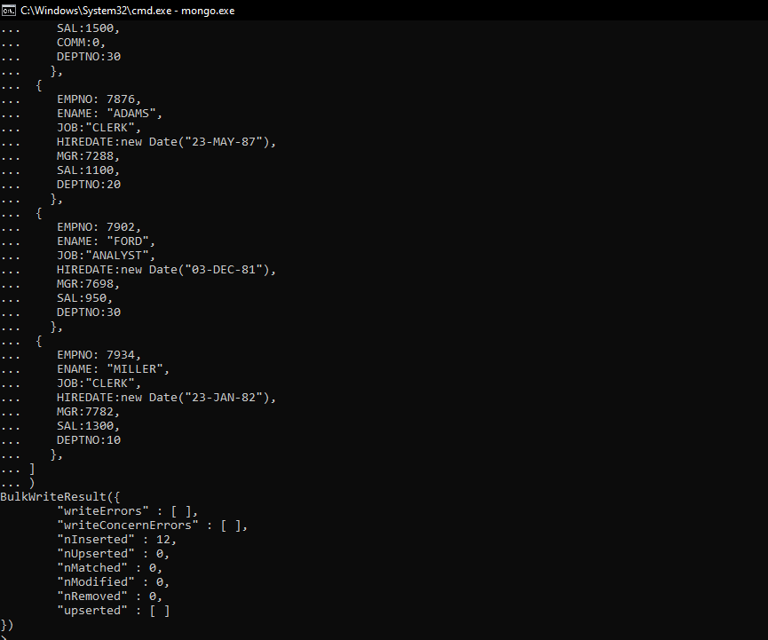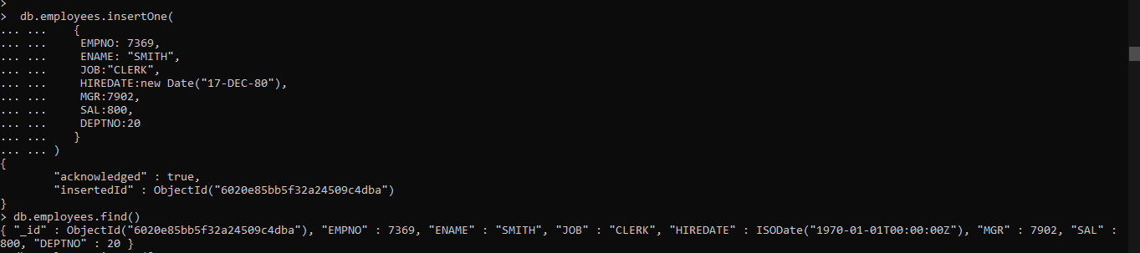

1. Display all the employee details

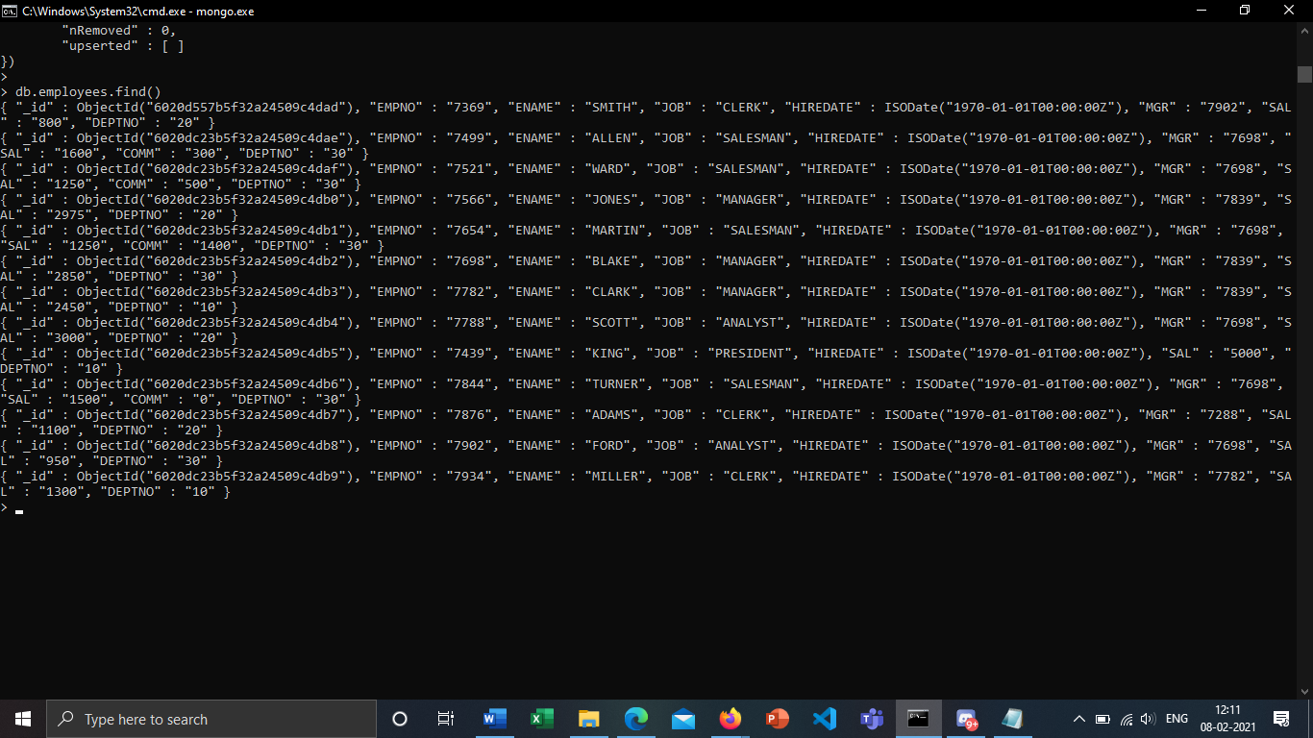

1. Display the ENAME of all the employees (Hint: use find() method)

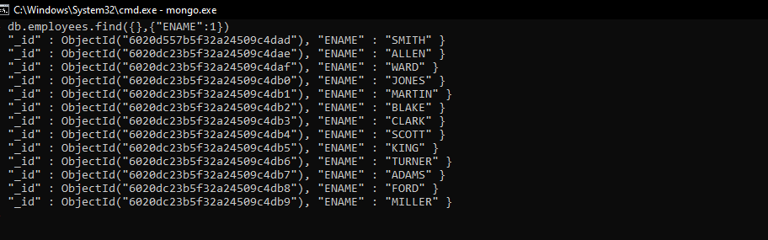

1. Display the ENAME, JOB of all the employees (Hint: use find() method)

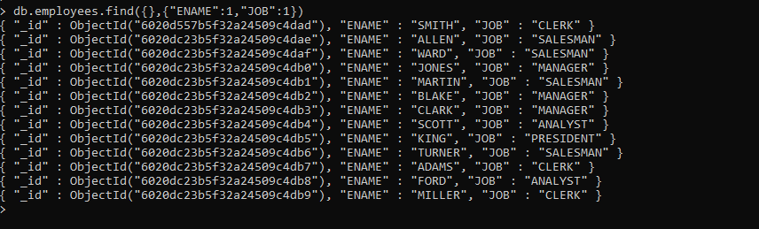

1. Display EMPNO, ENAME, JOB, HIREDATE of all the employees (Hint: use find() method)

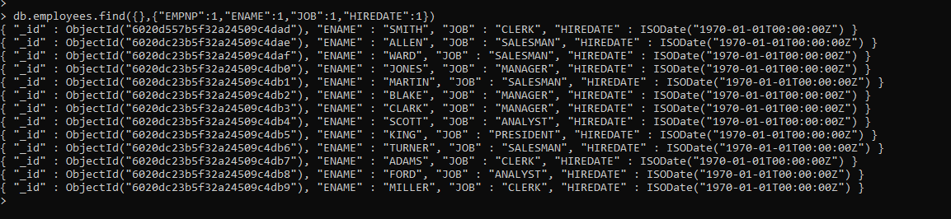

1. Display the details of all the employees in the ascending order of EMPNO (Hint: use sort() method)

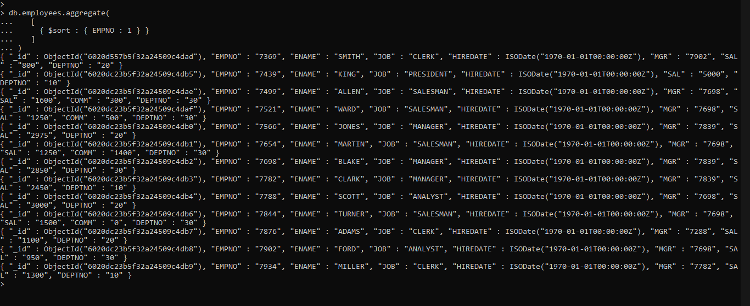

1. Display the details of all the employees in the ascending order of SAL (Hint: use sort() method)

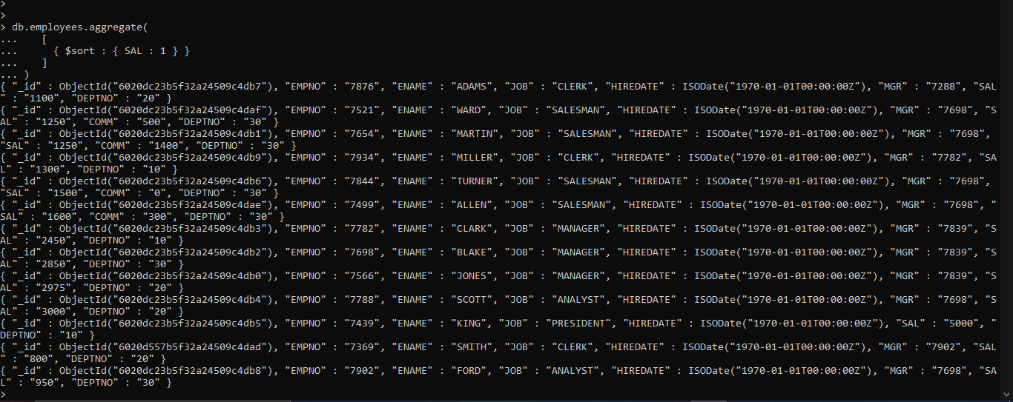

1. Display the details of all the employees in the ascending order of ENAME (Hint: use sort() method)

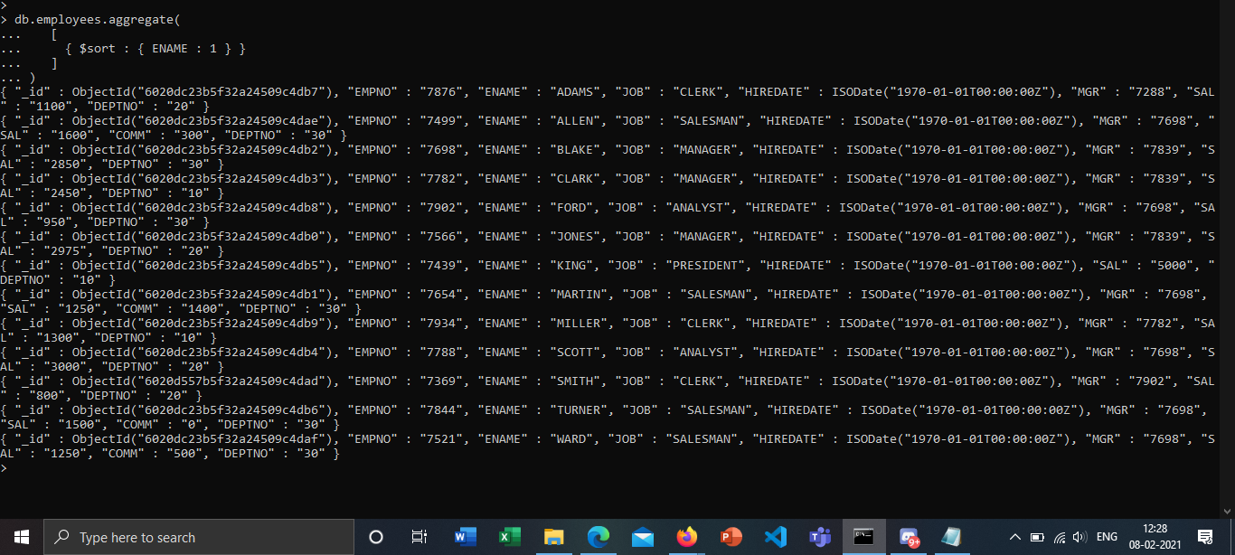

1. Display the details of all the employees in the descending order of JOB (Hint: use sort() method)

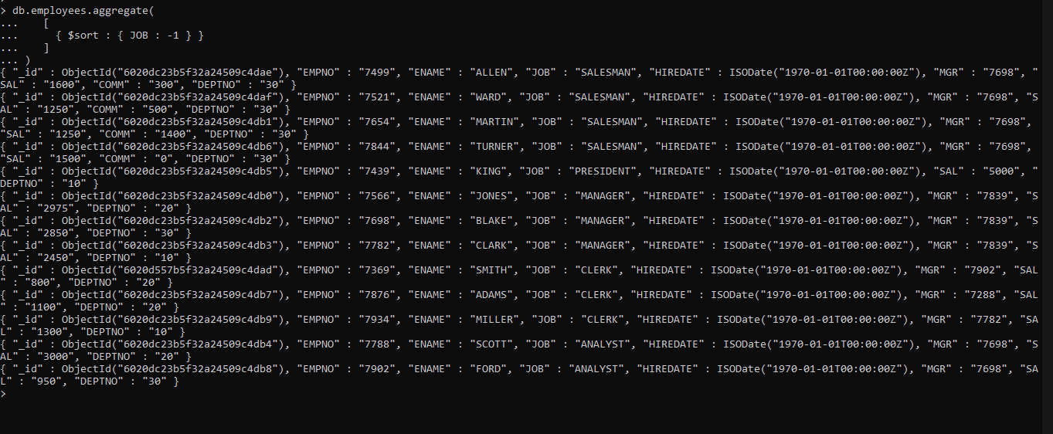

1. Display the details of all the employees in the descending order of DEPTNO (Hint: use sort() method)

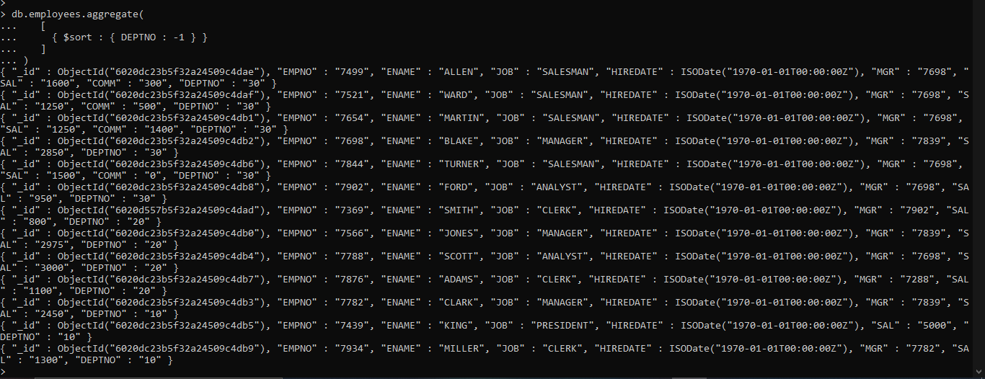

1. Display the details of all the employees in the descending order of ENAME(Hint: use sort() method)

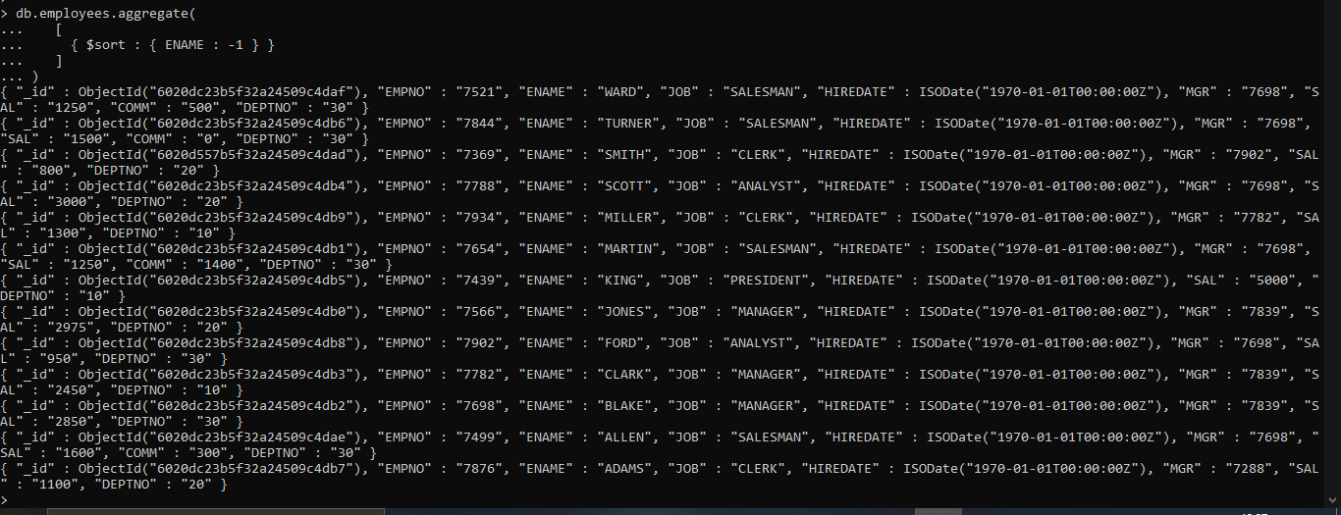

11. Display the sum of the salaries of all the employees (Hint: use aggregate() method) 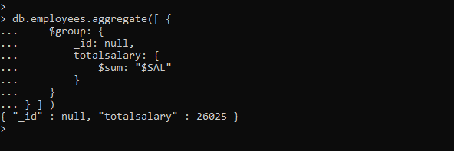

12. Display the average salary of all the employees (Hint: use aggregate() method) 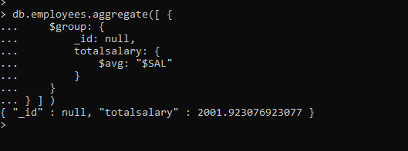

13. Display the maximum salary of all the employees (Hint: use aggregate() method) 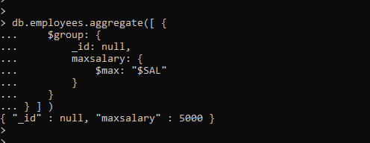

14. Display the minimum salary of all the employees (Hint: use aggregate() method) 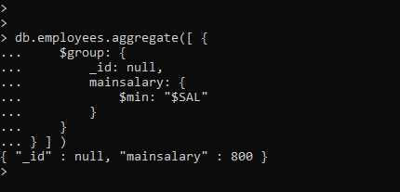

15. Display the First three rows of the employee details (Hint: use limit() method)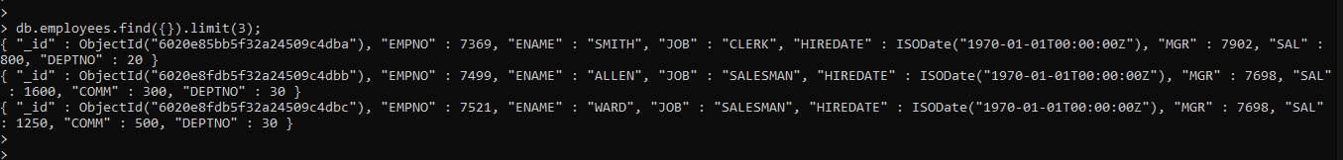

16. Display the First row of the employee details (Hint: use limit() method) 

17. Display the employee details except first five rows (Hint: use skip() method) 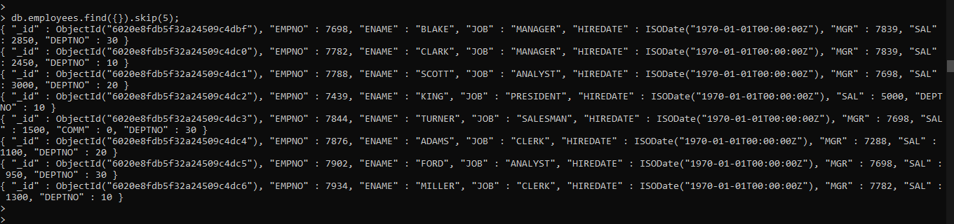

18. Display the employee details by skipping the first three rows (Hint: use skip() method) 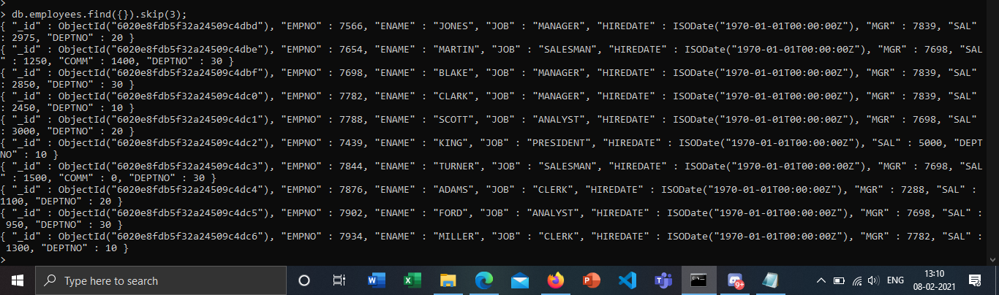

19. Display the employee details by skipping the first three rows (Hint: use skip() method) 

20. Display only the eighth document (row) of the employees (Hint: use limit(), skip() methods)

21. Display all the employee details whose salary is greater than 1500 (Hint: use find() method) 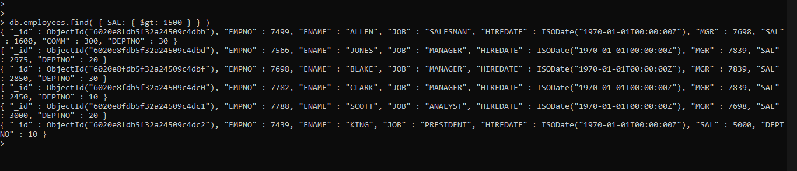

22. Display all the employee details whose salary is less than 1200 (Hint: use find() method) 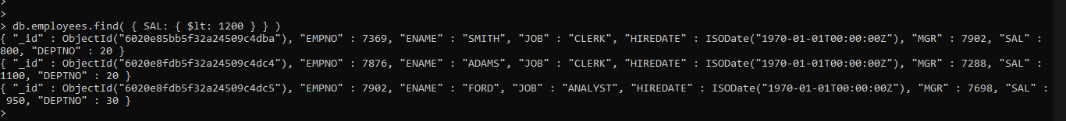

23. Display all the employee details whose salary is equal to 2450 (Hint: use find() method)

24. Display all the employee details whose salary is greater than 2500 and job is manager (Hint: use find() method) 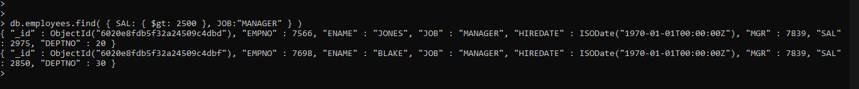

25. Display all the employee details whose salary is less than 1500 or job is clerk (Hint: use find() method)